

**Solo project**

**Kshitija Mishra**

**AU1920182**

**Topic: Memory Recall Accuracy task**

**Guided By: Professor Nithin George**

**GitHub link: <https://github.com/AU1920182/reports>**

**Review papers for reference: <https://www.jetir.org/papers/JETIR2201580.pdf>**

**<https://www.ncbi.nlm.nih.gov/pmc/articles/PMC2658622/>**

**Introduction:**

An exercise used to evaluate a person's capacity to recall and replicate information from memory is called a memory recall task. It entails giving previously taught content to participants and asking them to recall and articulate it. In psychological and cognitive research, memory recall tasks are frequently employed to comprehend different facets of memory functions. There are various kinds of memory recall exercises, such as:

1. **Free Recall:** Without the use of any particular cues or prompts, participants are asked to recall and recollect material. For instance, remembering a sequence of events or a list of words.

2. **Cued Recall:** To help with information retrieval, participants are given cues or clues. To stimulate memory, this may entail presenting a portion of the content that has been studied or a relevant context.

3.**Serial Recall:** Participants are required to recall and replicate data in a predetermined sequence. This is frequently used to evaluate memory's sequential correctness.

4.**Recognition Tasks:** Participants are asked to identify or recognize a series of elements that they remember, some of which were included in the original material.

**Paired-Associate Recall:** Pairs of objects, such as word pairs, are given to participants, who are then asked to recall the associated item when the other item is offered. This process is known as Paired-Associate Recall.

Memory recall tasks are crucial for researching cognitive functions including encoding, storing, and retrieval because they shed light on the variables affecting memory recall's precision and effectiveness. These exercises are frequently used to study memory function and malfunction as well as to create plans for enhancing memory performance in disciplines including psychology, neuroscience, and education.

1. **Retrieval Cues:** Retrieval cues, which can be internal (like related terms) or external (like contextual information), are generally necessary for memory to be successful.

2. **Encoding and Storage:** How information is first encoded (processed during learning) and stored (retained over time) affects memory recall tasks. Rehearsal, organization, and focus are important factors.

3. **Forgetting Curve:** The Ebbinghaus forgetting curve illustrates the gradual decline in memory retention. Tests of memory recall can be administered at different times to track patterns of memory retention and forgetting.

4. **Individual Variations:** Everyone's memory is different. Age, cognitive ability, and past experiences are a few examples of factors that can affect how well a person does on memory recall tests.

**Neurological Basis:** Activities involving memory recall are linked to brain activity in areas such as the prefrontal cortex and the hippocampus. The brain mechanisms behind memory retrieval can be better understood with the use of Neuroimaging techniques.

Researchers can investigate a variety of memory-related phenomena with the use of memory recall tasks. These include the influence of various factors on memory performance, the function of cognitive processes, and the creation of interventions to improve memory recall in diverse settings.

Since memory recall tasks require retrieving information from memory that has been stored, they are intimately related to working memory and accuracy. Let's investigate the relationships between working memory, accuracy, and memory recall:

1. **Accuracy in Memory Recall:**

Definition: The degree to which information that is retrieved matches the information that was initially encoded is known as accuracy in memory recall.

Connection: Memory recall tests are designed to evaluate people's retrieval and replication skills. The better someone has stored and retained the information, the more accurate the recall.

1. **Working Memory and Memory Recall:**

Working memory is defined as the system that manages the short-term storing and processing of information needed for continuous cognitive functions.

Link: In memory recall exercises, working memory is essential. Information that is actively being processed throughout the recall process is temporarily held there. Higher working memory capacity people frequently have more accurate recall.

**Influence of Working Memory on Recall Accuracy:**

Capacity: People with higher working memory capacities can often store and process more information at once, which may result in more precise recall.

Processing: During encoding and retrieval, working memory organises and processes information, which helps to improve recall accuracy.

**Retrieval Strategies and Working Memory:**

Utilization of Strategies: Retrieval techniques including chunking and association formation, which improve recall accuracy, are implemented by working memory.

Working memory plays a vital role in monitoring and updating recovered knowledge, which enables people to make corrections and enhance accuracy when recalling it.

**Task Complexity and Working Memory Load:**

**Neural Overlap:**

The stress on working memory increases with the complexity of a memory recall task. This is known as the load effect. Accuracy may suffer as a result, particularly in those with little working memory.

* **Brain Regions:** The prefrontal cortex is one of the brain regions that is activated during both working memory and memory recall activities. Accuracy-enhancing executive functions and control mechanisms are linked to these regions.

To grasp the cognitive processes behind memory retrieval, one must grasp the connections among working memory, accuracy, and memory recall tasks. In particular, in educational and therapeutic settings, researchers frequently look into these relationships in order to learn more about individual variances in memory performance and to create techniques for improving memory accuracy.

The Hermann Ebbinghaus forgetting curve is a key idea in the study of memory retention and recall accuracy. It was developed through self-experimentation in the late 19th century. The curve highlights how quickly memory recall accuracy declines after initial learning and highlights how easily forgotten material can be in its early stages. Over time, this reduction levels out, suggesting that information becomes more resilient to deterioration and forgetting rates drop down. Recall accuracy is critically impacted by timing, as the curve clearly illustrates; attempts to retrieve knowledge immediately after learning produce lower recall accuracy than retrieval after a wait. In addition, Ebbinghaus research highlights the importance of rehearsal and maintenance in preventing forgetting since they promote sustained memory accuracy. The forgetting curve has real-world implications for education as well. It suggests that spaced repetition and recurrent review can improve long-term retention, assisting people in navigating the temporal dynamics of memory and optimising recall accuracy over time.

•••**Hypothesis:**

* **Null Hypothesis (H0):** During the test phase, there is no discernible variation in the participants' memory recall and ability to differentiate between new and old words, according to the null hypothesis (H0).
* **Alternative Hypothesis (H1):** During the test phase, participants' abilities to recall and differentiate between old and new words will significantly change, according to the Alternative Hypothesis (H1).

**Dependent and independent variable:**

**Independent Variable:**

The type of information presented during the study phase.

Level 1: Old words (from the study phase)

Level 2: New words (not presented during the study phase)

**Dependent Variables:**

Recall Accuracy: The percentage of previously used terms that test participants successfully remembered.

Distinction Accuracy: The test-taking participants' capacity to accurately discern between new and old terms.

**Methods used:**

**Participants:**

Choose a sample of participants at random from the intended population. Every chosen participant is a student who is older than eighteen. Make sure the participants are unfamiliar with the words that will be delivered during the study phase.

**Study Phase:**

Display 19 arbitrary words on the screen for a predetermined amount of time. Tell the participants to commit the words to memory.

**Test Phase:**

Offer a combination of new and old terms (from the study phase).

The study requires participants to mark if they can remember every words from the study phase and to differentiate between new and old words presented in the test phase(press 'Y' for yes, 'N' for no).

**Statistical analysis:**

Calculate therecall accuracy for each participant and the d prime score for old and new words.

**To find the recall accuracy do the following steps:**

* Calculate the total number of correctly recalled words in the study phase (old words).
* Calculate the number of words correctly recalled but were not present in the study phase (new words).
* Add both of them and divide them by the total number of words presented during the test phase which is 19 in the experiment conducted.
* You will get your recall accuracy percentage.

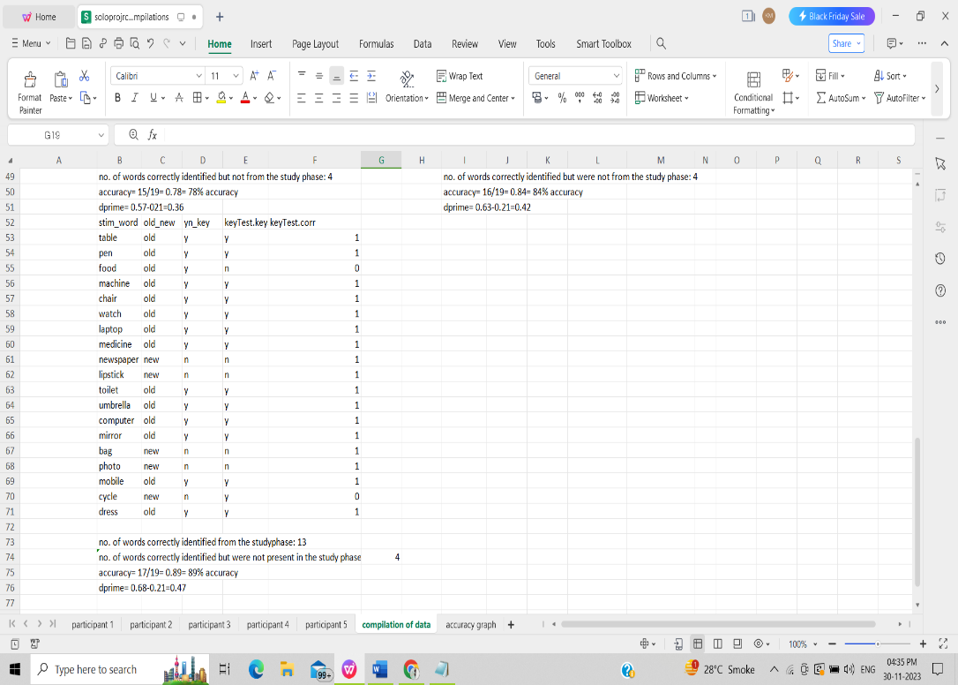

**D prime score finding method:**

* Calculate the total number of correctly recalled words in the study phase (old words).
* Calculate the number of words correctly recalled but were not present in the study phase (new words).
* Divide the total number of recalled old words by the total number of presented words in the test phase.
* Divide the total number of recalled new words by the total number of presented words in the test phase.
* Then subtract both of them to get the d prime score.

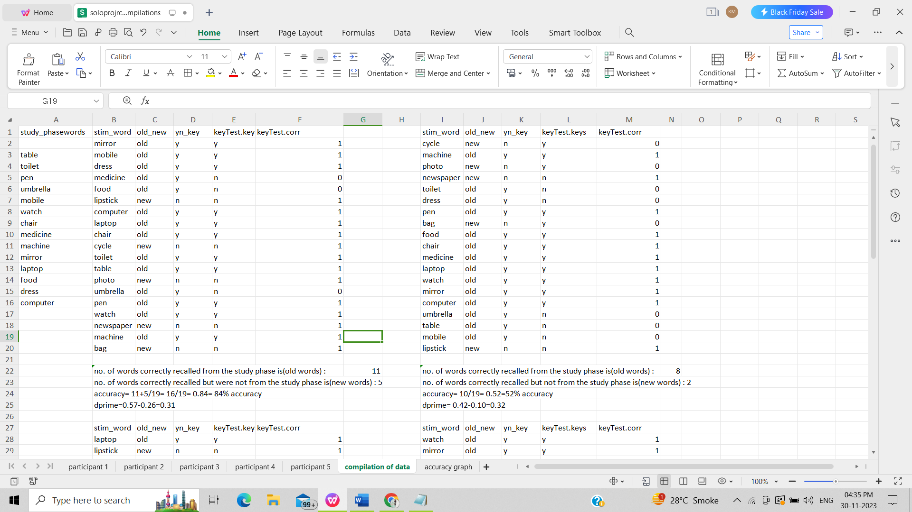

**Results obtained after the experiment is done:**

Results were obtained from the Excel sheet after the experiment was run on PsychoPy. Details are present in the link pasted above in GitHub.

|  |  |  |
| --- | --- | --- |
| Participant 1 | 84% | 0.31 |
| Participant 2 | 52% | 0.32 |
| Participant 3 | 78% | 0.36 |
| Participant 4 | 84% | 0.42 |
| Participant 5 | 89% | 0.47 |

In the above table, the accuracy percentage and d prime score are given according to the participant's recall accuracy.

The graph of recall accuracy obtained is given below:

In a graph showing memory recall accuracy, error bars are used to convey the variety and uncertainty of the data points. They show measurement precision, draw attention to statistical significance—or lack thereof—and provide information about the dependability and repeatability of experimental findings. Greater variability is indicated by larger error bars, which calls for a closer inspection of the experimental designs and data quality. Error bars improve the graph's readability overall and help readers comprehend the study's conclusions in greater detail.

**Conclusion:**

**Based on the data obtained I reject the null hypothesis and accept the alternate hypothesis because there is a significant difference in the participant’s ability to recall and distinguish between old and new words.**

**Ethical concerns before doing any experiment are as below:**

Here's a brief overview of ethical concerns in experimental research:

**Informed Consent:**

Concern: All information regarding the nature, goals, and dangers of the study must be provided to participants. Obtain informed and willing consent as a mitigation measure.

**Deception:**

Ethical concerns may arise from deceiving participants.

Reduction of deceit and debriefing are two mitigation strategies.

**Voluntary Participation:**

Concern: Make sure that participation is entirely voluntary and free from coercion.

Mitigation: Assure that withdrawals are permitted without repercussions. Maintaining confidentiality and safeguarding participant data are important concerns. Mitigation strategies include data protection, anonymization, and sharing data management protocols.

**Privacy:**

Concern: Throughout the study, respect participants' privacy.

Mitigation: Reduce privacy infringement in experimental design.

**IRB Approval:**

Concern: Seek Institutional Review Board (IRB) ethical approval.

Mitigation: Follow advice and send the study protocol for approval.

**Debriefing:**

Concern: Inform participants about the study and provide a post-study debriefing.

Mitigation: Hold debriefing meetings to talk about issues.

**Protection of Vulnerable Populations:**

Concern: Added security is required for populations that are more susceptible.

Mitigation: Obtain informed consent from duly appointed representatives as a mitigation measure.

**Beneficence and Non-Maleficence:**

Concern: Reduce harm and maximize benefits.

Mitigation: Give participant well-being a priority while doing a risk-benefit analysis.

**Data Handling and Storage:**

Concern: Make sure that participant data is handled and stored securely.

Mitigation: Use safe data storage techniques and adhere to privacy laws.

**Fair Treatment:**

Concern: Make sure that each participant is treated equally.

Mitigation: Create trials that encourage justice and equal treatment.

**The ethics PDF file is attached below:**

|  |  |  |
| --- | --- | --- |
| **Sr. No.** | **Title** | **Particulars** |
| 1 | Is approval by other Ethics Committee required? If ‘Yes’ mention the details. | NO |
| 2 | Type of review requested | **Exempted Review**/ Expedited Review/ Full Committee Review |
| 3 | Justify why a human study is needed to answer the research questions. | A human study is necessary to assess memory recall accuracy and the capacity of working memory. |
| 4 | Participant recruitment process and eligibility criteria | Participants are recruited, and eligibility criteria include being above 18 years old. |
| 5 | A number of participants are required with necessary justification. | 5 participants are tested to evaluate memory recall accuracy. |
| 6 | Justify inclusion and exclusion of vulnerable population | none |
| 7 | Procedure for seeking and obtaining informed consent with a sample of the patient/participant information sheet and informed consent forms in English and local languages. [AV recording if needed]  Informed consent for stored samples | Informed consent is obtained, and no participant details are disclosed. |
| 8 | Plan for statistical analysis of the study | Data from 5 participants are analysed, and accuracy rates are graphically plotted. |
| 7 | Explain the plans to maintain confidentiality of  records/data of the study participants | No data is leaked, and participants' details are not disclosed. |
| 8 | Explain all anticipated risks (adverse events, discomfort) or injuries that may be caused to the participant | none |
| 9 | Efforts taken to minimize the risk of injury | Yes, appropriate measures are taken. |
| 10 | Whether 'wage compensation' for the research subjects will be provided? [Compensation/ Reimbursement of incidental expenses and management of research-related injury/illness] | yes |
| 11 | Expected 'benefits' to volunteer / community | Yes, there are expected benefits. |
| 12 | Account of storage and maintenance of all the human material or data obtained from the study | Yes |
| 13 | Explain the plans for publication of results (positive or negative) while maintaining confidentiality of personal information/identity | pub med |
| 14 | Specific ethical issues, as identified by the investigating team | yes |
| 15 | List of documents enclosed for ethical review | None |